**EXPERIMENT 2:**

Configure IP address to routers in packet tracer. Explore the following messages: ping responses, destination unreachable, request timed out, reply.

**OBSERVATION:**

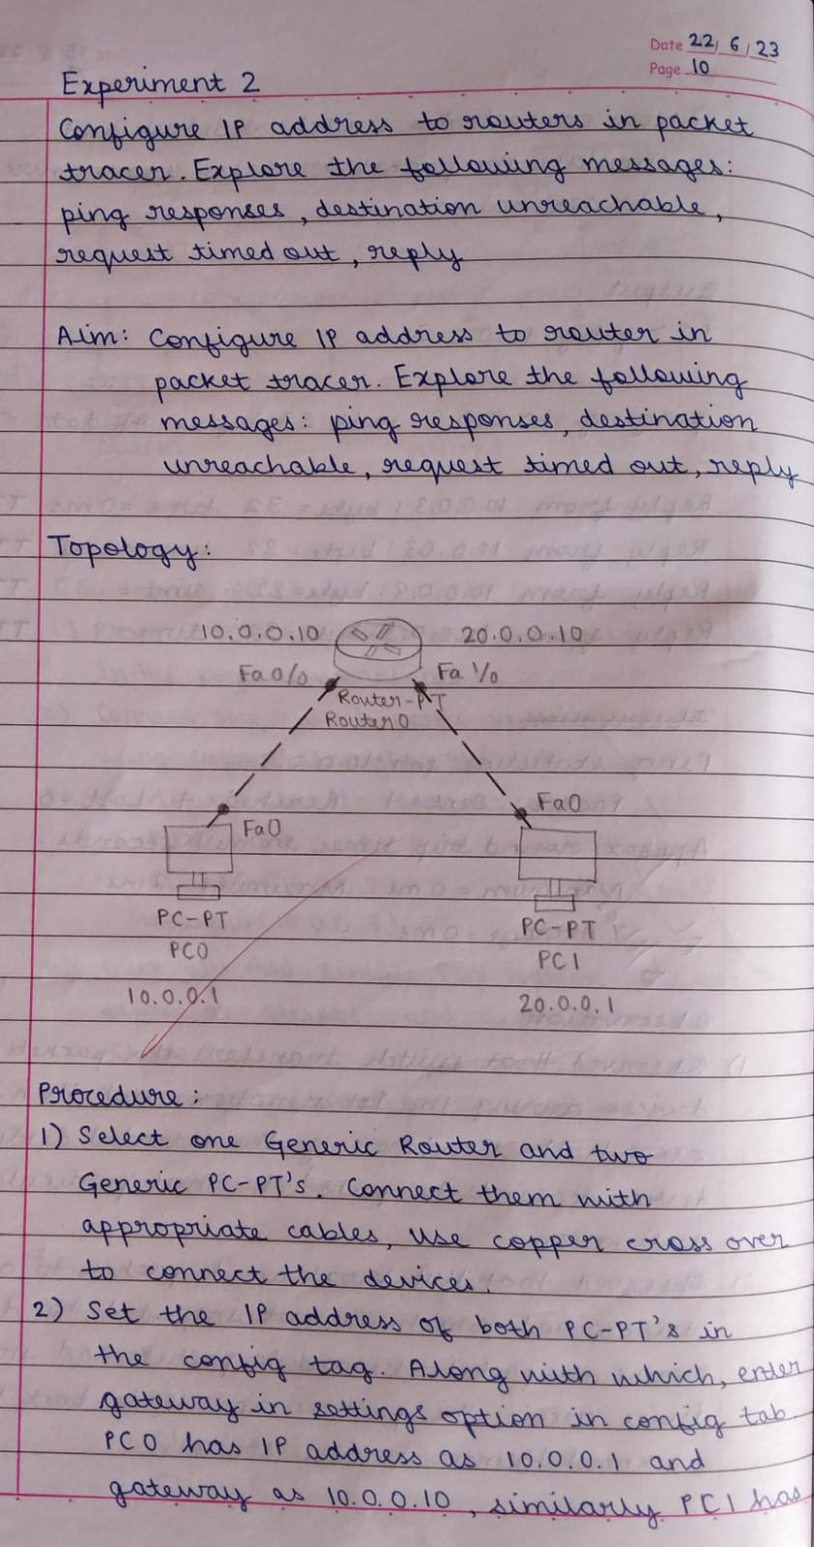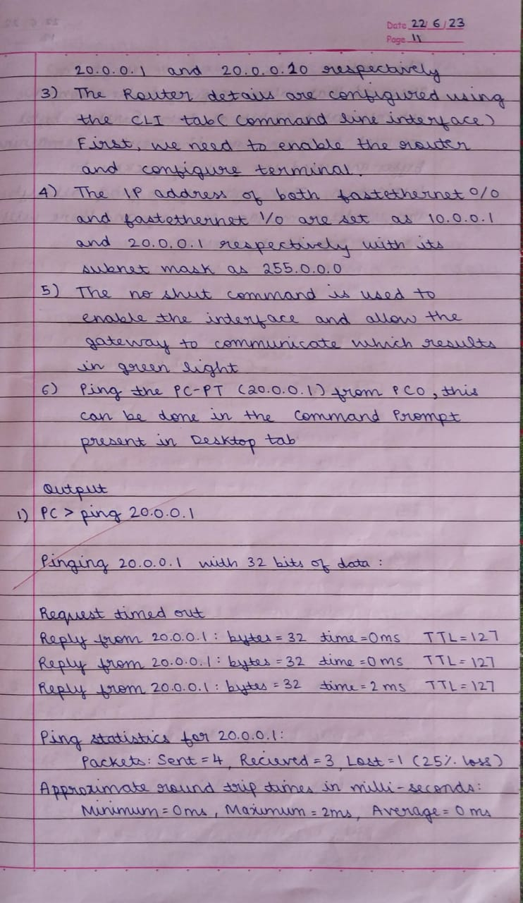

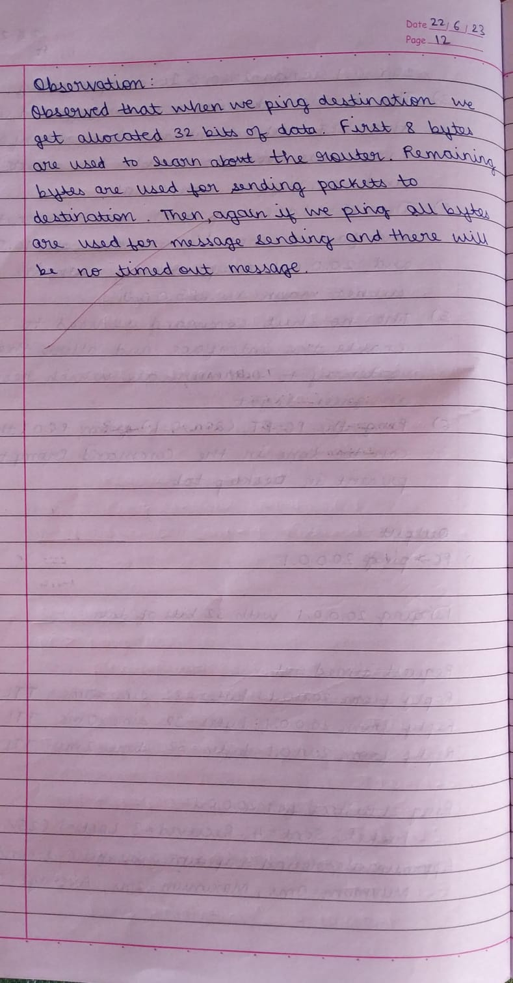

Output:

Before Configuring Gateway:

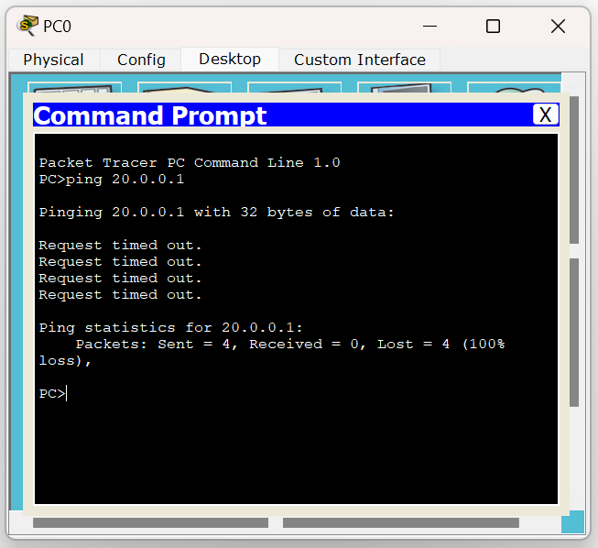

Before Configuring Gateway:

